Your Agentic AI Strategy

1. Find out more about how you’ll apply the content from this course to your own context
You’ll use this document ("Your Agentic AI Strategy") and its companion, “Your A.G.E.N.T. Playbook”, throughout the course to collate and explore your key ideas for applying agentic AI in your own context. Here is a summary of the course content you'll focus on in this document and your second document:
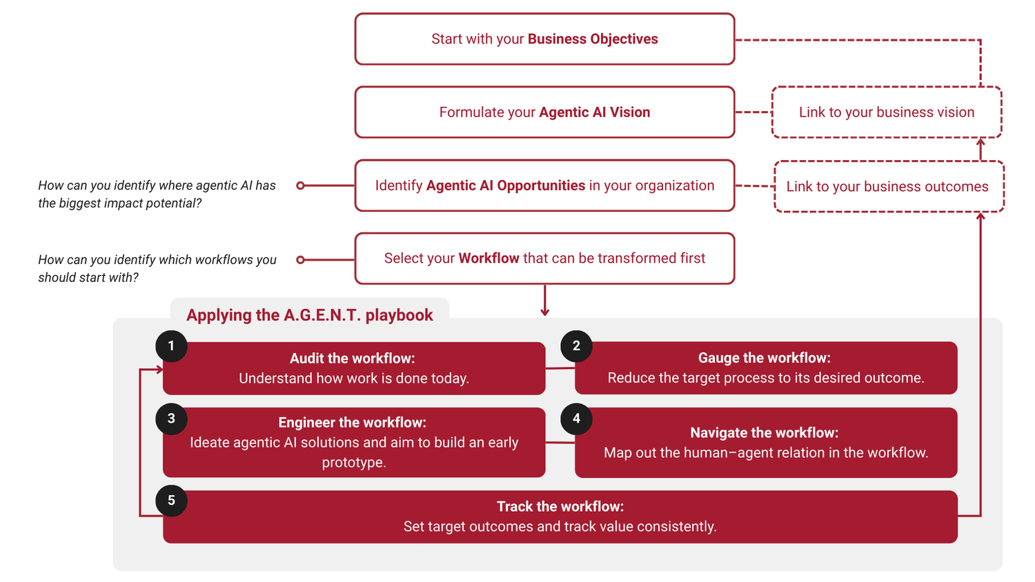
First, you’ll collate key information about your organization’s ability to create agentic AI workflows in this document, using the Strategic Building Blocks in the Data and AI Readiness (DAIR) model:
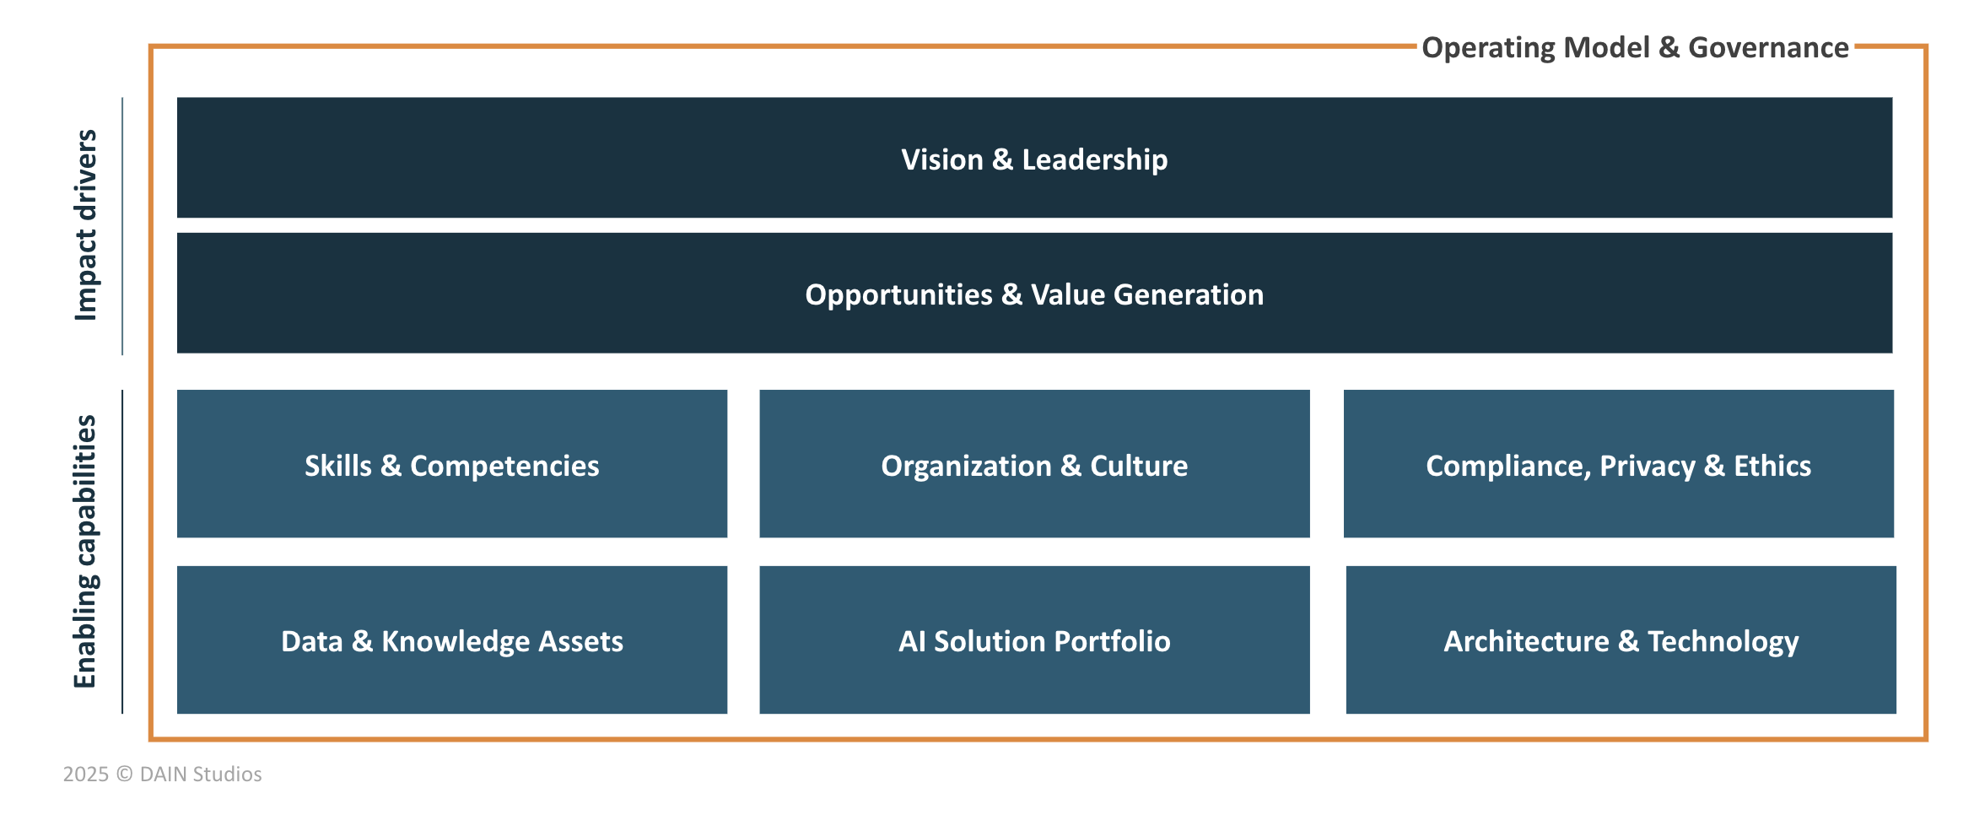
This model should help you reflect on the capabilities that are required, and potentially missing in your organization or individual context, to generate lasting value from this technology.

2. Your Enabling Capabilities
Now, reflect on the key capabilities at AI For Global Good that enable this value generation. This is a general reflection of your organization and an opportunity to prioritize the parts of the business setup that need further attention to enable AI integration. This does not need to be specific to the use of agentic AI only. You can reflect on the use and integration of AI generally.
Note that when "Data & AI" are used in this course, it refers to solutions with core elements of data, analytics, or AI (including dashboards, traditional analytics, machine learning, GenAI, agentic AI, and future technologies).
Finally, we are focusing this reflection on the enabling capabilities that you highlighted in the previous exercise as the key factors to make AI For Global Good - IDM ready for AI adoption.

Enabling Capabilities
Organization & Culture
Definition: The structuring of data, analytics, and AI teams, and the cultivation of a culture that fosters collaboration between business and technology stakeholders. It emphasizes behaviors and mindsets that normalize and reward data-driven decision-making, experimentation, and adoption of AI in workflows. Forward-looking change management ensures the organization is prepared for the wider impact of AI and automation on roles and ways of working.
Your reflection:
For AI for Global Good — IDM, I want the organizational culture to support the same core objective I valued at IDM: bringing together research, disease modeling, software engineering, and data to develop scientifically rigorous tools that can support global health research and decision-making.
The organization should be designed around collaboration between researchers, modelers, software engineers, and AI capabilities rather than treating AI as a separate technical function. Experimentation should be encouraged, but AI adoption should also be supported by clear scientific review, governance, reproducibility, and human oversight.
Because AI for Global Good is being designed from the beginning, there is an opportunity to make these principles part of the operating model rather than adding them later.
A shared organizational approach to AI should include:
- Clear decision rights: define who can approve AI use in scientific and disease-modeling workflows, what requires scientific or technical review, and what teams or agents can execute autonomously.
- Human accountability: AI agents may perform or coordinate work, but responsibility for scientific conclusions, important decisions, and released outputs should remain clearly assigned to people.
- Common standards: establish expectations for evaluation, documentation, provenance, reproducibility, validation, responsible AI use, and human oversight.
- Defined ownership: every AI-enabled workflow, model, tool, or agent should have an identifiable owner responsible for its maintenance, evaluation, and appropriate use.
- Collaboration across disciplines: researchers, disease modelers, software engineers, data specialists, and AI systems should work within shared workflows rather than operating as isolated functions.
- Reusable capabilities: prioritize AI components, tools, agents, datasets, and workflow patterns that can be reused across diseases and modeling projects instead of building independent solutions for every use case.
- Shared learning mechanisms: capture successful patterns, failures, risks, evaluations, and lessons so that knowledge gained in one project can improve future work.
- Leadership and governance: AI adoption should be an explicit organizational capability with clear priorities and boundaries, rather than something driven only by individual experimentation.
For agentic AI in disease modeling, I think one of the most important principles is to establish clear boundaries between what an agent can do autonomously and what requires human or scientific review. Agents can help gather evidence, analyze data, execute workflows, coordinate tools, run models, and generate candidate outputs, but the organization should explicitly define where human judgment and scientific accountability are required.
AI Solution Portfolio
Definition: The breadth, scalability, and operationalization of data & AI solutions. This portfolio covers both internally developed and vendor-provided solutions, with clear strategies for make-or-buy decisions, vendor management, and alignment with business priorities. Effective lifecycle management frameworks (AIOps, MLOps, LLMOps, AgentOps) ensure solutions are reliable, maintainable, and deliver sustained business impact.
Your reflection:
For AI for Global Good — IDM, I would define the AI solution portfolio around a clear objective: build and support AI capabilities that strengthen disease modeling, scientific research, and public-health decision support.
Because this is a new organization, I would not start with a large collection of disconnected AI tools. I would build the portfolio deliberately, starting with a small number of high-value use cases and expanding only when they demonstrate scientific and operational value.
The portfolio should distinguish between:
- Exploratory AI solutions: prototypes used to test whether an idea is scientifically useful and technically feasible.
- Project-specific solutions: AI capabilities built for a particular modeling or research workflow.
- Reusable capabilities: components, agents, tools, or services that can support multiple disease areas or projects.
- Production-supported solutions: capabilities with defined ownership, documentation, evaluation, monitoring, and long-term maintenance.
For agentic AI, I would prioritize solutions where agents can meaningfully coordinate multi-step scientific workflows—for example, gathering evidence, preparing data, running analyses or simulations, comparing outputs, documenting results, and escalating decisions that require human scientific review.
Before moving an AI capability from experimentation into the supported portfolio, I would evaluate it against a few clear criteria:
- Scientific value: Does it improve the quality, speed, reproducibility, or usefulness of disease-modeling work?
- Public-health relevance: Does it contribute meaningfully to research or decisions that support the organization's mission?
- Reuse: Can it support multiple projects, disease areas, or scientific workflows?
- Reliability: Are its outputs sufficiently consistent and testable for its intended use, with appropriate human review?
- Operational readiness: Is there clear ownership, documentation, evaluation, monitoring, and support?
- Risk: Are privacy, scientific, ethical, security, and misuse risks understood and manageable?
- Sustainability: Does the expected value justify the cost and effort required to maintain it over time?
- Interoperability: Can the capability integrate with the organization's modeling tools, data systems, and other AI agents without creating unnecessary duplication?
I would also use a deliberate build-versus-buy decision process. Capabilities that are scientifically differentiating or tightly connected to disease-modeling methods may justify internal development, while commodity capabilities may be better provided through external platforms or services.
The goal is not to maximize the number of AI solutions. The goal is to maintain a small, coherent, reusable, and scientifically valuable portfolio where each supported solution has a clear purpose, owner, lifecycle, and connection to the mission of AI for Global Good.
Data & Knowledge Assets
Definition: Storage, availability and management of data and knowledge across structured and unstructured sources. Explicit processes ensure ongoing enhancement, maintenance, and discoverability, improving data depth, accessibility, and readiness for data & AI use cases, including GenAI and other agentic AI systems.
Your reflection:
For AI for Global Good — IDM, data and knowledge assets should be treated as part of the scientific infrastructure, not simply as inputs to individual projects.
Because the organization is being designed from the beginning, I would want data, modeling code, documentation, assumptions, configurations, and research outputs to be organized so that both people and AI agents can discover, understand, connect, and reuse them responsibly.
For agentic AI, I would prioritize the assets that provide the scientific context needed to interpret and reproduce disease-modeling work correctly:
- Model documentation and assumptions: so agents understand what a model represents, its limitations, its intended use, and why important modeling decisions were made.
- Datasets and their context: including source, provenance, methodology, transformations, quality considerations, licensing or access restrictions, and version used.
- Code repositories: so agents can connect scientific intent and documentation with the actual implementation.
- Model configurations and parameters: including scenarios, assumptions, parameter sources, calibration settings, and versions associated with a particular analysis.
- Research literature and evidence: so agents can connect modeling assumptions and parameters to the scientific evidence supporting them.
- Research outputs and supporting analysis: so results can be traced back to the data, code, configurations, assumptions, and evidence that produced them.
- Evaluation and validation artifacts: including tests, comparisons, calibration results, model validation, and AI-agent evaluations that help determine whether an output is reliable enough for its intended use.
A major priority would be making these assets discoverable together rather than independently. An AI agent responding to a scientific question should ideally be able to move from the question to the relevant literature, data, model, code, assumptions, parameters, and previous outputs while preserving the relationships between them.
For example:
Scientific question → evidence → data → model → assumptions → parameters → execution → results → interpretation
That connection is especially important for disease modeling because an output without its scientific context can easily be misunderstood or reproduced incorrectly.
I would therefore treat provenance and traceability as core requirements for the knowledge architecture. AI agents should not only retrieve information; they should also be able to identify where it came from, which version was used, how it relates to the model, and what assumptions or limitations apply.
The goal for AI for Global Good would be to develop a connected scientific knowledge environment where researchers, modelers, engineers, and AI agents can access the same underlying evidence and maintain a traceable path from scientific evidence to modeling decisions to results.
Compliance, Privacy, & Ethics
Definition: Clear rules, responsibilities, and procedures that ensure legal, regulatory, and ethical requirements for data and AI are consistently met. This includes privacy protection, fairness, transparency, accountability, and alignment with internal and external standards and initiatives. Organizational awareness and dedicated roles embed compliance and ethical considerations into decision-making and AI deployment, including guardrails for the operations of increasingly autonomous AI agents.
Your reflection:
For AI for Global Good — IDM, compliance, privacy, ethics, and scientific integrity should be built into the organization from the beginning, especially because the work may involve health data, research datasets, external data sources, and increasingly autonomous AI systems.
For agentic AI, I would want clear guardrails around what agents can access, what actions they can take, how those actions are recorded, and when human review is required. These controls should be proportional to the risk of the task: an agent searching public literature should not require the same level of oversight as an agent modifying a disease model, accessing restricted data, or generating conclusions intended to influence public-health decisions.
At a high level, I would establish requirements in the following areas:
- Data privacy: Define what data can be used by AI systems, with particular attention to identifiable, sensitive, partner-provided, licensed, or restricted health and research data.
- Access control: Define which users, agents, and services can access specific datasets, repositories, models, tools, and internal systems. Agents should receive only the permissions necessary to complete their assigned tasks.
- External AI services: Establish rules for what information can and cannot be sent to external model providers, APIs, or third-party tools.
- Consent, licensing, and data-use agreements: Ensure that AI use remains consistent with the original consent, licensing terms, data-sharing agreements, and permitted research purposes.
- Data retention: Define how long prompts, outputs, logs, uploaded data, intermediate files, and agent-generated artifacts are retained and who can access them.
- Autonomous actions: Establish explicit boundaries between actions agents may perform independently and actions that require human approval.
- Scientific validation: Require appropriate scientific review before AI-generated assumptions, model changes, analyses, interpretations, or conclusions are treated as scientifically valid.
- Traceability and reproducibility: Maintain records of data sources, model and code versions, parameters, prompts, tool calls, agent actions, important decisions, and resulting outputs.
- External communication: Require appropriate review before AI-generated scientific findings, interpretations, recommendations, or model outputs are published or shared with external stakeholders.
- Fairness and representativeness: Evaluate whether datasets, assumptions, models, or AI-generated recommendations could systematically underrepresent or disadvantage particular populations or geographic regions.
- Accountability: Every AI-enabled workflow should have a clearly identified human owner. - - Responsibility should not become ambiguous simply because an agent performed part of the work.
- Incident handling: Define what happens when an AI system produces an incorrect, unsafe, scientifically misleading, privacy-violating, or otherwise non-compliant result, including how the issue is documented, investigated, corrected, and prevented from recurring.
For AI for Global Good, I would use a risk-based governance model rather than applying the same controls to every AI use case. The greater the potential impact of an agent's action, the stronger the requirements for validation, authorization, monitoring, and human oversight.
A key principle for the organization would be:
AI agents may perform work, but they should not remove human accountability for scientific and public-health decisions.
This is particularly important in disease modeling, where a technically valid output can still be scientifically misleading if the underlying assumptions, evidence, population context, or limitations are not understood.
The goal would be to create an environment where AI can increase the speed and scale of scientific work without weakening privacy, scientific rigor, transparency, reproducibility, or accountability.

3. Your Agentic AI vision
Clarify your destination — now that you have reflected on the different parts of AI for Global Good — IDM, and considered where you need to invest most of your effort for implementing AI, let’s now focus on your organization’s vision for Agentic AI.
3.1 It is useful to start with your business objectives at hand to ensure your vision aligns with what AI for Global Good — IDM, is trying to achieve. What are the current strategic priorities and main objectives of your organization?
For AI for Global Good — IDM, the main objective is to use AI to make disease modeling more accessible, reproducible, efficient, and useful for public-health research and decision-making.
For the initial phase, I would keep the priorities focused:
- Build AURORA-TB as the first proof of concept.
- Start with tuberculosis in Indonesia, rather than trying to address multiple diseases or countries at once.
- Use available scientific evidence and public data to support the modeling workflow.
- Test whether Agentic AI can help move from a research question to an epidemiological model and intervention scenarios.
- Preserve evidence provenance, reproducibility, uncertainty, and human scientific oversight.
- Design the first implementation so that components could eventually be reused for other diseases or countries, without trying to solve that generalization during the first project.
The immediate goal is therefore not to build a global disease-modeling platform. It is to demonstrate that an AI-assisted modeling workflow can work reliably for one meaningful epidemiological problem.
The current proposal is Indonesia as the MVP rather than expanding the geography too early.
3.2 Agentic AI refers to systems that can take initiative, act autonomously toward goals, and collaborate with humans to achieve better outcomes. Thinking of your organization - what role could such AI play in achieving your organization's priorities and objectives?
Agentic AI could help connect steps of the disease-modeling workflow that currently require a researcher to manually move between literature, datasets, model assumptions, simulations, and results. For the first AURORA-TB implementation, I would keep this simple. The system could support three main functions: Evidence & Data: Find relevant evidence and data, extract useful parameters, and record their sources. Modeling & Simulation: Use those inputs to configure a TB model and run a limited number of intervention scenarios. Validation & Reporting: Check results against expected epidemiological behavior and produce a report showing results, uncertainty, assumptions, and provenance. A human researcher remains in the loop, especially for approving assumptions, reviewing model configuration, and determining whether results make scientific sense. So the role of Agentic AI is not to replace the epidemiologist or modeler. It is to coordinate and perform well-defined parts of the scientific workflow while keeping the evidence and decisions traceable. This is a simplified implementation of the broader AURORA-TB workflow, which originally separates evidence, provenance, modeling, calibration, intervention, simulation, validation, and reporting responsibilities.
3.3 Now imagine AI For Global Good - IDM in 3–5 years, when agentic AI is fully integrated. What does that world look like? How do people, processes, and decisions work differently?
In 3–5 years, I would like AI for Global Good to have a reusable Agentic AI framework that helps researchers develop and evaluate disease models without rebuilding the entire workflow for every new research question.
In that environment:
- Researchers focus more on scientific questions, assumptions, interpretation, and decisions.
- AI agents handle more of the repetitive work of finding evidence, organizing data, configuring analyses, running simulations, and documenting results.
- Models remain connected to the evidence, data, assumptions, and parameters that produced them.
- Human review is built into important scientific decisions rather than added at the end.
- Successful components from one disease-modeling project can be adapted to another.
I would want the progression to happen gradually:
one disease + one country → validated workflow → additional contexts → reusable disease-modeling capability
AURORA-TB therefore becomes the starting point, not the finished product.
The longer-term project already anticipates this type of progression: Indonesia first, followed potentially by the Philippines and later Peru to test whether the architecture transfers to a substantially different epidemiological context.
3.4 How does this vision support your business model and strategy? E.g. Does it enhance customer value, operational scalability, differentiation, or sustainability?
The vision supports the strategy of AI for Global Good in several ways:
- Scalability: A reusable agentic workflow could allow a small team to support more modeling questions without increasing effort proportionally.
- Scientific value: The system combines automation with provenance, validation, and human review rather than generating unsupported answers.
- Differentiation: The focus is not simply on using generative AI, but on applying Agentic AI to evidence-grounded scientific modeling.
- Reusability: Components developed for AURORA-TB could later support other diseases and populations.
- Sustainability: Automating repetitive workflow steps could allow researchers and engineers to spend more time on scientific reasoning and model development.
For the initial project, however, I would not try to prove all of these benefits at once. The first measure of success is much smaller:
"Can AURORA-TB complete a useful portion of a TB modeling workflow while producing scientifically reviewable and traceable results?"
If that works, scalability and reuse can become later objectives.
3.5 Agentic AI brings autonomy, but also responsibility. What values or principles should guide your use of Agentic AI (e.g., human-centricity, transparency, sustainability)?
For AI for Global Good - IDM, I would want our use of Agentic AI to be guided first by scientific integrity and responsibility. Because we are working with disease modeling, the goal should not be to automate as much as possible, but to use AI where it genuinely improves the quality, speed, and reproducibility of the work.
The principles I would want us to follow are:
- Scientific integrity: AI-generated results should not automatically be considered scientifically valid. Important assumptions, model changes, and conclusions still need scientific review.
- Evidence grounding: The system should be able to show where its data, parameters, and assumptions came from, rather than producing answers without supporting evidence.
- Transparency and traceability: We should be able to understand what the AI did, which tools or data it used, and how it arrived at important outputs.
- Human accountability: AI can perform and coordinate parts of the workflow, but people should remain responsible for the scientific interpretation and final decisions.
- Reproducibility: A researcher should be able to understand and reproduce the process that produced a result, including the data, model version, assumptions, and configuration used.
- Responsible autonomy: Agents should be allowed to work independently when the task is low risk and well defined, but actions with important scientific or public-health consequences should require human review.
- Privacy and responsible data use: Health and research data should only be used in ways that are consistent with privacy, consent, licensing, and data-sharing requirements.
- Simplicity and usefulness: I do not want to add AI or create multiple agents just because we can. The system should remain as simple as possible and use Agentic AI only where it clearly improves the scientific workflow.
For me, the main principle is that AI should strengthen the researcher, not replace scientific judgment. In AURORA-TB, that means allowing agents to do useful work across evidence gathering, modeling, simulation, and reporting, while keeping the process transparent and making sure a human researcher remains responsible for the final scientific conclusions.
For now the MVP will cover:
Research Question
↓
1. Evidence & Data Agent
Find evidence/data + extract parameters + preserve sources
↓
2. Modeling & Simulation Agent
Configure a simple TB model + run selected scenarios
↓
3. Validation & Reporting Agent
Check outputs + identify uncertainty + generate traceable report
↓
Human Review
I think that is still genuinely agentic because the system is pursuing a goal, selecting/using information and tools, handing work between stages, evaluating results, and potentially revising its work. But it is realistic enough that I can build and demonstrate it during a short timeframe intensive rather than spending the course engineering an elaborate multi-agent platform.
3.6 Review and edit your vision statement below:

Vision Statement
Our vision is to empower researchers, disease modelers, and public-health decision-makers to develop more accessible, reproducible, and evidence-grounded disease models through reusable agentic AI workflows, enabling faster and more scalable scientific analysis for global health, while ensuring scientific integrity, transparency, and human accountability.

4. Your opportunity identification and workflow prioritization
Select the opportunity and workflow that you could focus on throughout the course.
4.1 What is the team, business function, or functional area of the value chain that you want to focus on throughout this course?
Disease Modeling and Scientific Research
For AI for Global Good - IDM, I want to focus on the disease-modeling function, specifically the process of turning epidemiological evidence and data into models that can be used to explore disease dynamics and evaluate potential interventions. For this course, I will use AURORA-TB as the initial use case, focusing on tuberculosis modeling in Indonesia.
4.2 List the common high-level workflows or processes in your selected team or function. (For example, Invoicing, Payroll, Contracting, etc.)
The main workflows in the disease-modeling function are:
- Define the research question and scope
- Gather relevant scientific evidence and epidemiological data
- Identify model parameters, assumptions, and their sources
- Configure the disease model
- Run simulations and intervention scenarios
- Review and validate model outputs
- Analyze and interpret results
- Create an interactive results dashboard
- Present key model outputs, intervention scenarios, uncertainty, assumptions, and data sources in an accessible form.
- Deploy the dashboard using Vercel or a similar web platform so results can be easily explored and shared.
- Document results and provenance
- Preserve the evidence, assumptions, parameters, model configuration, limitations, and sources behind the results.
- For the course, I would focus on this workflow:
Research Question → Evidence & Data → Parameters & Provenance → Model Configuration → Simulation → Validation → Dashboard & Reporting
For AURORA-TB, the dashboard would be the final user-facing output of the workflow. It could allow a researcher or public-health decision-maker to explore a small set of TB intervention scenarios and see:
- Baseline versus intervention results
- Key epidemiological outcomes
- Assumptions and parameters used
- Uncertainty or limitations
- Evidence/data sources
- When the analysis was generated
For the MVP, I would deliberately keep the dashboard simple. The agents generate the analysis and results, and the dashboard visualizes already-generated outputs. I would not initially have the Vercel application launch simulations dynamically. That can come later.
So the architecture becomes very manageable:
Agentic workflow → model results → structured output (JSON/CSV) → Vercel dashboard

